Welcome to the Cody’s Original Roadhouse Hourly Training Program. We are excited for you to be a part of our team and to teach you everything we can in order for you to be a success at Cody’s. Please fill in the facts below so that you can have the proper information if something is to arise during your training process. Please bring this study guide and quiz packet to class every day.

Cody’s Original Roadhouse Restaurant Information

1. **MANAGEMENT STAFF:**

GENERAL MANAGER: ___________________________ MANAGER: ___________________________

MANAGER: ___________________________

KITCHEN MANAGER: ___________________________

2. **ADDRESS: _______________________________________________________**

3. **PHONE NO: _____________________**

**WEBSITE ADDRESS:** www.codysoriginalroadhouse.com

4. **HOURS OF OPERATION:**

OPEN 7 DAYS PER WEEK

Monday thru Thursday: 3:00 PM - 10 PM

Friday and Saturday: 3:00 PM – 11 PM

Sunday: 11:00 AM - 10 PM

**NOTE:** **Opening & Closing times may vary – check your restaurant hours.**

**NOTE:** Restaurants Restaurant is always ready 15 minutes prior to opening. Also, will stay open 15 minutes past posted closing time.

|  |  |  |  |
| --- | --- | --- | --- |
| Training Schedule for the Week | | | |
|  | Date | Time | Trainer |
| Day 1 |  |  |  |
| Day 2 |  |  |  |

Dish Training Process Overview

**Options for training times:**

9:00-10:45 Set-up of area with Trainer

10:45-1:30 Follow

1:30-2:00 Clean-up/Re-stock of area with Trainer

2:00-3:00 Class with Food Show, Quiz review, Evaluation

**OR**

4:00-4:45 Set-up of area with Trainer

4:45-7:00 Pre-Meal/Follow

7:00-8:00 Class with Food Show, Quiz review, Evaluation

8:00-Close Hands on/Clean-up/Re-stock of area with Trainer

Day 1

***Class Topics-***

* Dish Duties and Responsibilities
* Mechanics of Dish
* Dishwasher Opening Duties Timeline
* Floor Cleaning Procedures
* Low Temp Dish Machine Instructions
* Flatware Soaking Procedures
* Prep Procedures

***Follow Topics-***

* Round Robin: 30 minutes in each area. PREP and LINE
  + Prep- Observe mechanics, set-up, sanitation, and recipe adherence
  + Line- Observe proper mechanics, communication, plate set up, and flow of kitchen
* Dish- Follow trainer to observe proper set up, mechanics, communication, and sanitation

Dish Responsibilities and Duties

This position is responsible for maintaining cleanliness and sanitation standards for china, glassware, tableware, cooking utensils, etc., using machine and manual cleaning methods. This position also ensures the dishwashing area is maintained as a clean, safe and sanitary facility.

As a dishwasher your job responsibilities include, but not limited to:

* Sort and rinse dirty dishes, glass, tableware and other cooking utensils and place them in racks to send through dish machine.
* Sort and stack clean dishes. Carries clean dishes to cook’s line and other proper storage areas. Rewashes soiled dishes before delivering.
* Sort and stack clean pots, pans and utensils. Carries clean pots, pans, and utensils to cook’s line and other proper storage areas. Rewashes soiled dishes before delivering.
* Change dishwater in dish machine every 2 hours or as needed.
* Wash pots, pans and trays by hand.
* Remove trash and garbage to dumpster.
* Set up or break down dishwashing area.
* Clean and roll/unroll mats.
* Set-up clean linen bags.
* Fill/empty soak tubs with cleaning/sanitizing solutions.
* Sweep/mop floors.
* Assemble/disassemble dish machine.
* Sweep up trash around exterior of restaurant and garbage dumpster.
* General restaurant and restroom cleaning as directed.
* Wipe up any spills to ensure kitchen floors remain dry and therefore prevent any unnecessary slips or falls.
* Must notify Manager anytime dish machine wash or rinse cycle falls below safety standard temperatures.
* Must notify Manager anytime dish machine wash or rinse cycle runs out of chemicals.
* Never touch dirty dishes before touching clean dishes without washing hands first.
* Other duties as directed.

The Mechanics of Dish

1. Place dishes in racks. Do not stack dishes on top of each other. Water must have access to both sides of the dishes.
2. Stand plates and all flatware up edgewise.
3. Cups, glasses, and bowls should be inverted open end down, so the items will not fill up with water.
4. Allow dishes to air dry for about 1 minute before removing from racks. Do not towel dry or stack when wet. These two things will contaminate the dishes and are health violations.
5. Do not touch the surface of any plates or glasses that the guest's mouth will touch, this is a health violation.
6. Store any pots, pans, bowls, cups, etc., upside down.
7. Pick-up clean silverware and utensils by the handles only.
8. Store all clean kitchenware at least 6" off the floor in a clean and dry area.
9. Rewash soiled dishes before carrying out.
10. Allow cast-iron plates to air-dry before taking them back to the grill.

*QUALIFICATIONS TO ENSURE DISHES HAVE BEEN PROPERLY WASHED*:*

A. Dishes must be clean and free of all food particles.

B. No spots or stains.

C. All soap rinsed off.

D. No chips or cracks – if so, show management and discard. (This is a health violation).

E. Hot from 180° rinse water. (Consult a manager if necessary for dish machine temperature accuracy).

* Run back through dish machine if all qualifications are not met.

***REMEMBER:***

***TO HELP GET DISHES CLEAN THE FIRST TIME, CHANGE WATER EVERY 2 HOURS. NOT CHANGING THE WATER OFTEN ENOUGH WILL CAUSE YOU TO WASH THE SAME DISHES MORE THAN ONCE.***

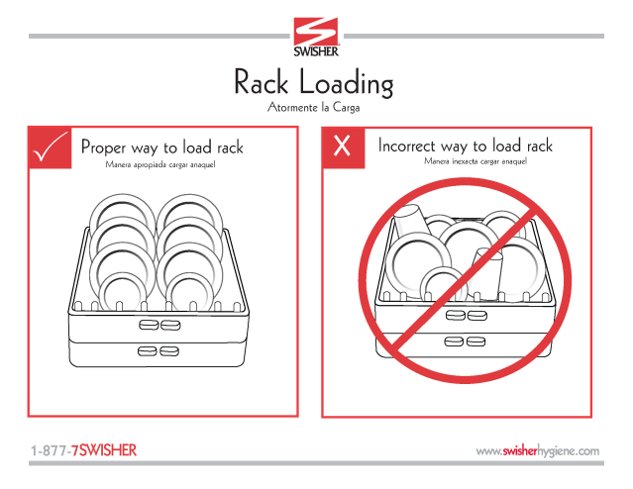

Dishwasher Opening Duties Timeline

Every morning the Opening Dish Duties Timeline laminate must be followed. This is to ensure all responsibilities of the dishwasher position are accomplished in a timely manner. The Dish washer is a very important function and touches 100% of the guests who dine in the restaurant. All responsibilities will be met if this timeline is followed.

***Dishwasher Duties***

**9:00am**

Set up linen bags and lay out mats. Pull any trash outside to dump.

**9:25am**

Re-assemble dish machine, turn on. Check dish chemical levels on machine and all dispensers.

**9:35am**

Clean both restrooms:

• Clean and sanitize toilets and sinks focus on basins, stainless steel and inner bowls (use proper chemicals and tools).

• Clean mirrors (use glass cleaner and paper towels)

• Refill all paper towels, toilet paper and hand soap dispensers.

• Clean all baby changing stations and refill paper pads if necessary. Advise manager of any broken pieces.

• Take out trash if needed (check sanitary receptacles in Women’s Room stalls and replace with new disposal bag).

• Clean all partitions and any stainless

• Check to ensure no burnt-out light bulbs

**10:30am**

Fill mop bucket ½ full with floor cleaner.

Spot sweep areas in the restaurant that are needed.

Scrub and clean the designated area of the restaurant as well as the bathrooms. (Remember to change water periodically).

**2:00pm**

Begin prepping potatoes per the KM’s guidance. Prep other items with the prep department as directed by the KM.

When washing potatoes for today’s prep. Allow potatoes to air dry *completely* while you perform other prep items. (This may be done ahead of time, the night before)

**2:30pm**

Check parking lot and sweep areas needed.

• Be sure to check rock/mulch beds for trash and cigarette butts.

• Be sure to get the corners of the curbs.

• Clean “dumpster pad”.

**4:00pm**

Catch up dishes to keep the dish area organized.

**9:30pm**

Ensure potatoes are completely dry before oiling and salting. Follow KM guidance for par.

Complete side work and check out with a manager when cut.

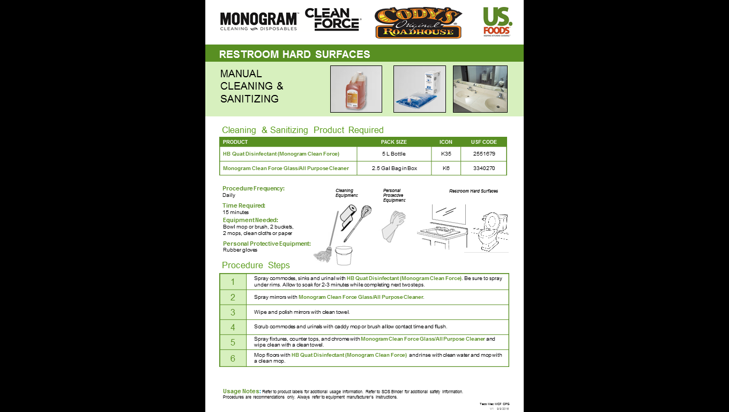

Floor Cleaning Procedures

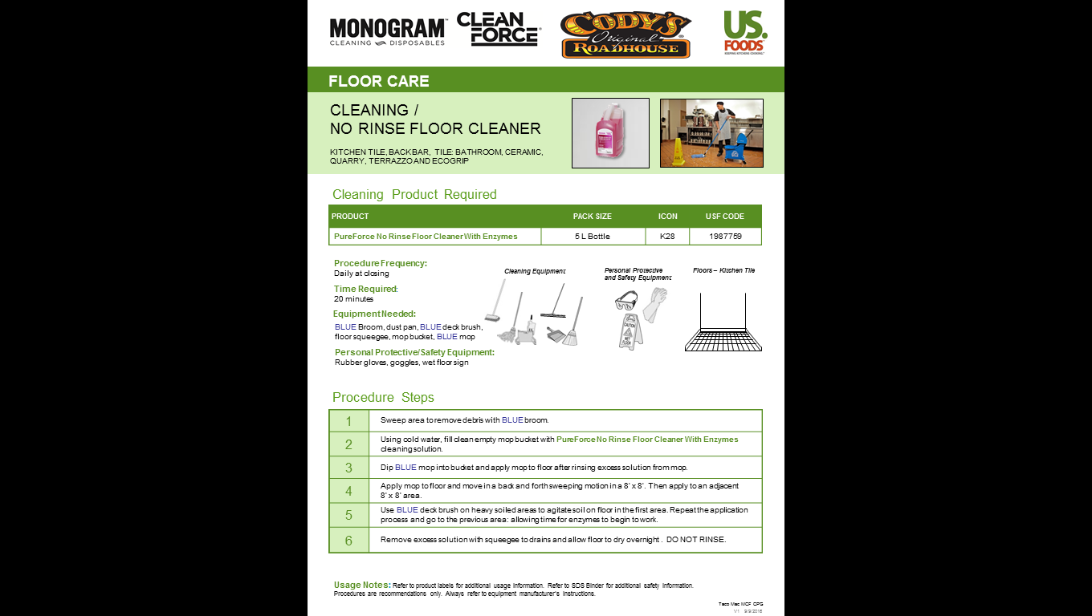

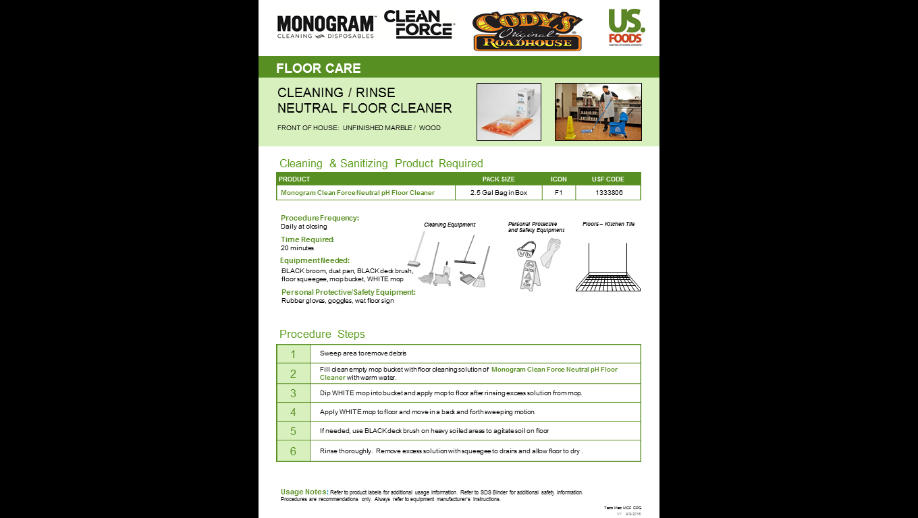

Low Temp Dish Machine Instructions

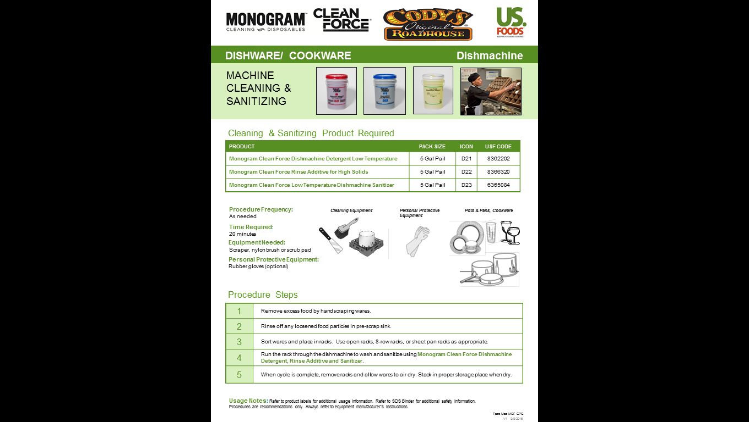

Pot & Pan Hand Wash Instructions

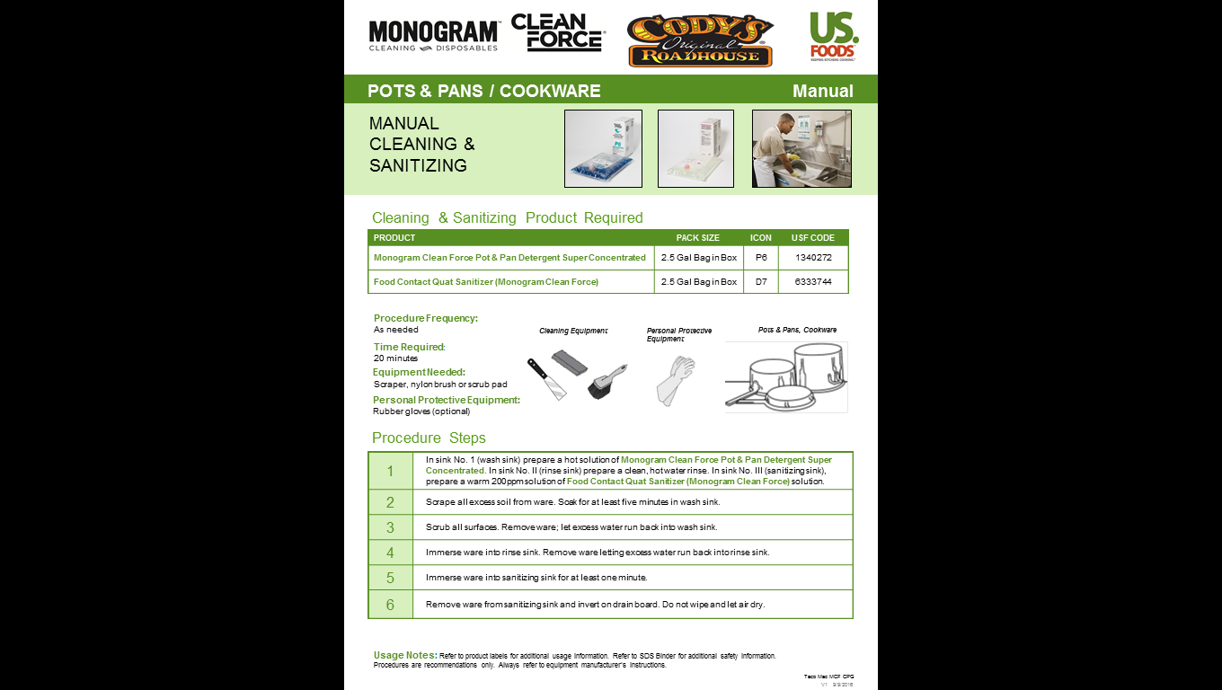

Flatware Soaking Procedures

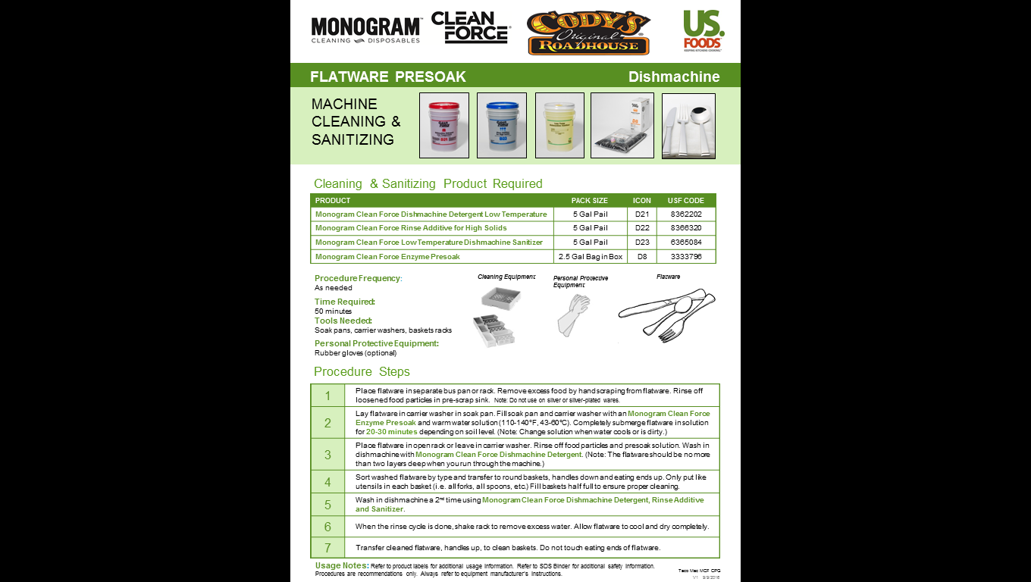

Prep Procedures

Along with the restaurant cleaning duties, dish machine functions and health and safety procedures, another job function is to assist with prep items or during peak periods on the cook’s line. As listed on your Opening Job Functions Timeline, dish is solely responsible for the prep of baked potatoes, sweet potatoes, and bread (where applicable).

Bakes & Sweets Prep

We wash both of our sweet potatoes and baked potatoes to remove the roots (we also remove any “bad spots” as needed). Both potatoes have to be allowed to *completely* dry before continuing. The dried potatoes are then oiled and salted. With that being said, preparation and staging is the key to making this prep item! Each of these recipes must be followed accurately. Ensure the kitchen manager gives you an hourly potato count so you can set up your rack with that number of potatoes on a sheet tray.

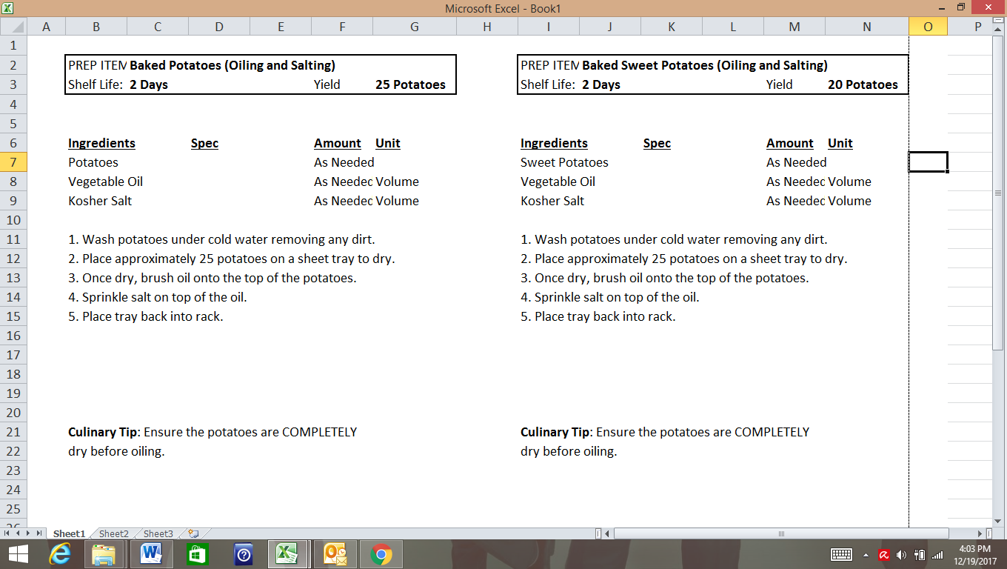

**Cody’s Original Roadhouse Dish Day 1 Quiz**

**Name: _________________________________ Score ______/10**

1. How often should the water in the dish machine be changed?
2. Every 30 minutes
3. Every 45 minutes
4. Every 1 hour
5. Every 2 hours
6. All clean kitchenware must be _____ inches off of the floor in a clean and dry area.

A) 3

B) 6

C) 8

D) 10

1. You should always use a dry towel to dry dishes. True or False
2. Stacking wet dishes is a health code violation. True or False
3. The dish machine should be re-assembled and turned on at ____ as a part of the opening duties for your location.
4. Baked potatoes should be completely dry before oiling and salting. True or False
5. How much water should be added to the EZ Floor solution while filling the mop bucket?
6. 2 gallons
7. 3 gallons
8. 4 gallons
9. None of the above
10. The floor cleaning solution should be rinsed once the floor has been scrubbed with a deck brush.

True or False

1. Match the following temperature to the correct dish machine cycle.
2. 80 to 110 degrees F ______ Pre- Wash Cycle
3. 150 to 165 degrees F ______ Final Rinse/ Sanitize Cycle
4. 120 to 140 degrees F ______ Wash Cycle
5. Flatware is placed handle up in the flatware basket. True or False

Day 2

***Class Topics-***

* SDS Sheets
* Chemical Labeling Requirements
* Sanitizer Test Procedures
* Trash Audits

***Follow Topics-***

* Trainer to review location of chemical storage and labeling
* All Health and Safety Standards are discussed

SDS Sheets

****An “SDS” (Safety Data Sheet) is a collection of all of the information regarding the chemicals we use in the restaurant. If it is a chemical used in the restaurant, it needs to be in this book. The information listed on the chemicals ranges from its intended use to its level of causticity, safety handling procedures, etc. This is typically located in the dish area, and you need to be aware of its location, should the information ever be needed quickly. (Accidental exposure, health department request, OSHA request etc.)

Chemical Labeling Requirements

Requirements for labeling of chemical containers come from the Occupational Safety and Health Administration (OSHA) Hazard Communication and Laboratory Safety standards. All hazardous chemicals are required to be properly labeled (full chemical name) unless they are exempted by this standard.

Labels on purchased chemicals must include:

1. The common name of the chemical
2. The name, address and emergency phone number of the company responsible for the product
3. An appropriate hazard warning

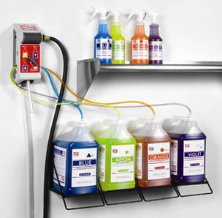

The warning may be a single word - "danger", "warning" and "caution" - or may identify the primary hazard, both physical (e.g., water reactive, flammable or explosive) and health (e.g., carcinogen, corrosive, or irritant). Most labels will provide you with additional safety information to help you protect yourself while working with substances. This includes protective measures to be used when handling the material, clothing that should be worn, first aid instructions, storage information and procedures to follow in the event of a fire, leak or spill.

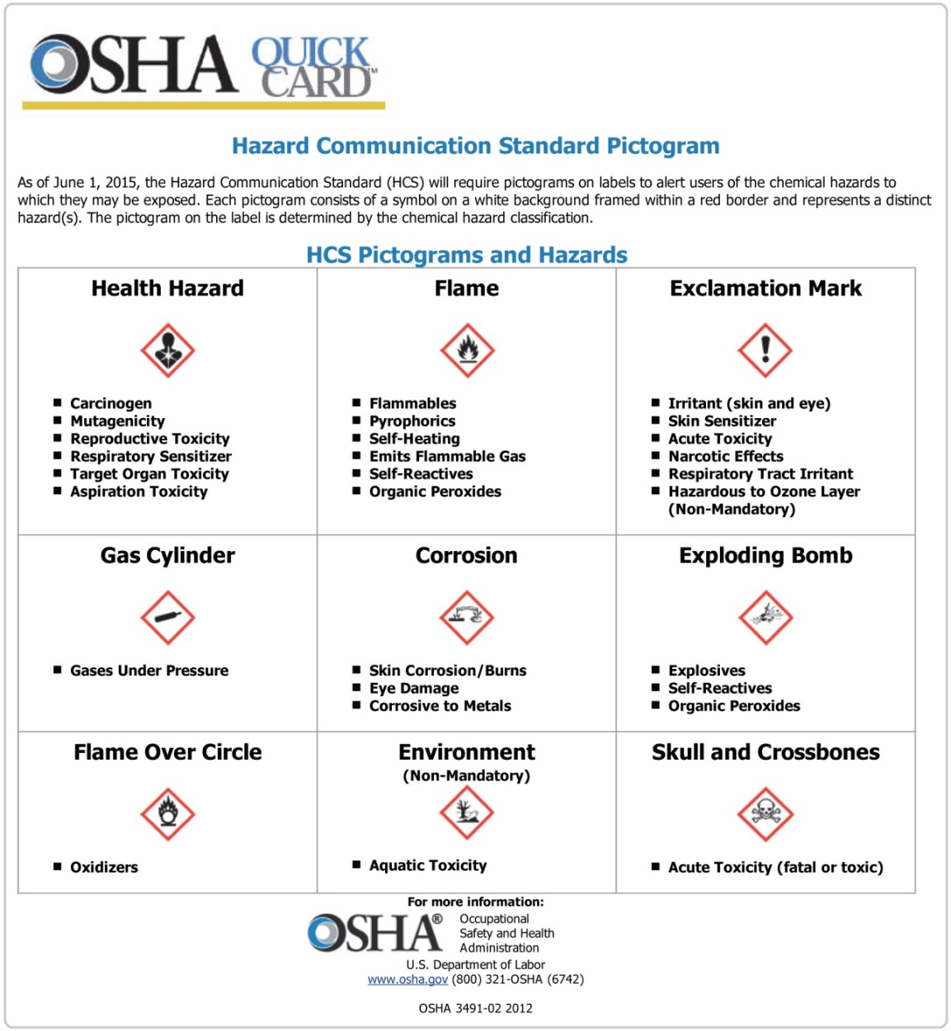

Sanitizer Test Procedures

Microbial contamination is the food industry’s main safety concern. Public Health Regulations require that all inanimate food contact surfaces be properly cleaned and sanitized to protect the public health from exposure to the hazards of disease transmitted through the cross-contamination of surfaces soiled with infectious micro-organisms.

The soiling of food contact surfaces with germs takes place in the normal course of preparing, handling, and consuming food. Any surface which comes in contact with uncooked meat, poultry, or fish may become contaminated with bacteria such as E. coli. EPA has recognized that surfaces and articles such as glasses, dishes, and utensils that become soiled with infectious microorganisms found in bodily fluids (saliva and/or blood) can be associated with potential for the transmission of disease. In order to prevent this sanitizer buckets with two towels are set up throughout the restaurant. Any time a surface is cleaned it must also be sanitized.

There are 3 forms of chemical sanitizer- quat, chlorine and a Covid-19 Contact Surface Cleaner Sanitizer. Quat (short for Quaternary Sanitizer) is an ammonia-based solution where chlorine is a bleach-based solution. Both sanitizers must be changed at a minimum every 2 hours or when needed and tested to ensure proper strength. Quat sanitizer should read no more than 200 PPM (parts per million), chlorine sanitizers should read no more than 50 PPM and Contact Surface Sanitizer should be within the color chart on the side of the test strip container.

It is important to know there are three different test strips for each of these sanitizers. We use a quat sanitizer or Contact Surface Cleaner Sanitzer in our buckets. This chemical should be mixed with warm water at 80°F (25°C) for best results. See the chart below for the proper use of the test strips.

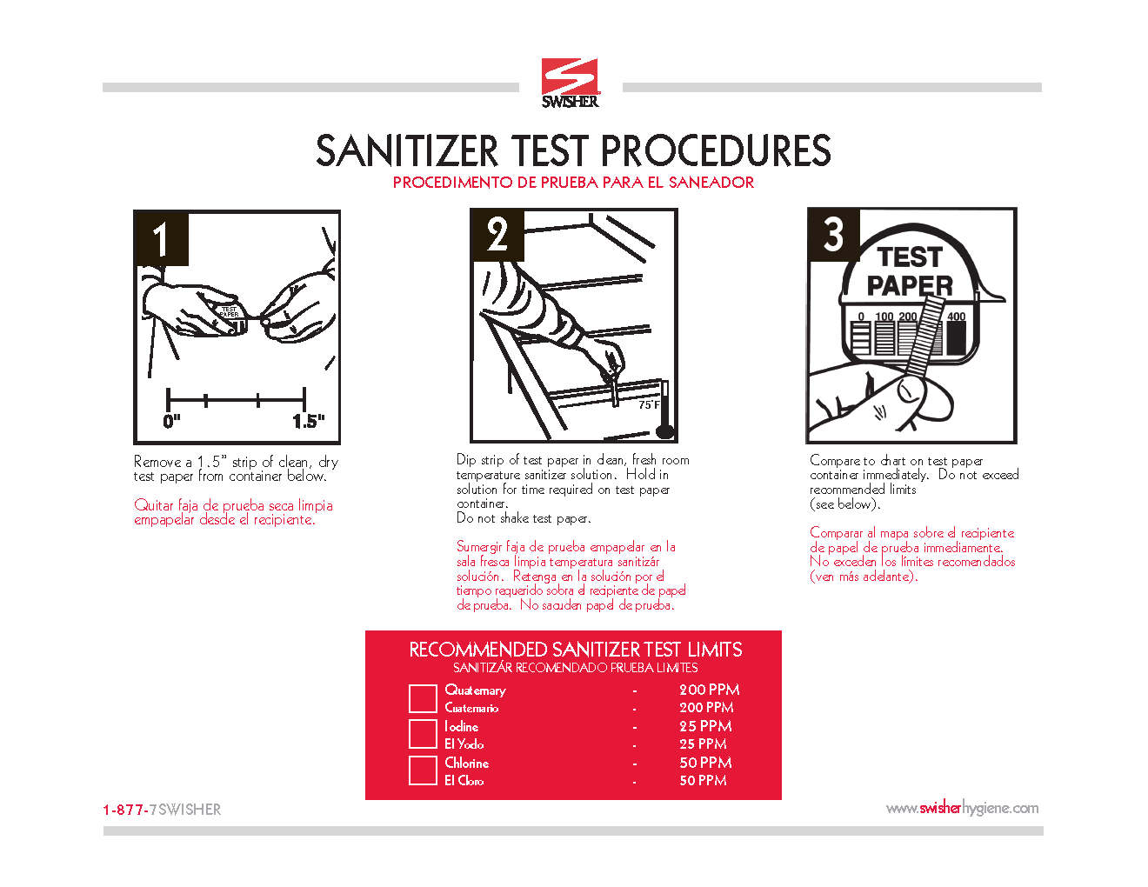

3 Compartment Sink

The 3-compartment sink is required in our restaurants as a backup to the dish machine. If the dish machine ever goes down, this is where all of the dishes would have to be washed. Therefore, the sink system has chemicals attached and ready to go. These include a pot/pan detergent and a sanitizer. This sink follows the standard restaurant flow of “wash-rinse-sanitize”. Depending on the layout of your restaurant, the sink will either run left-to-right or right-to-left. Attached in this packet is a chart of both versions. Only one will apply to your sink.

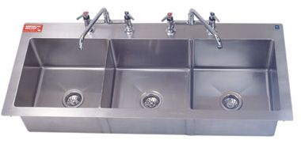

**Wash**

**Rinse**

**Sanitize**



**Wash**

**Sanitize**

**Rinse**

-OR-

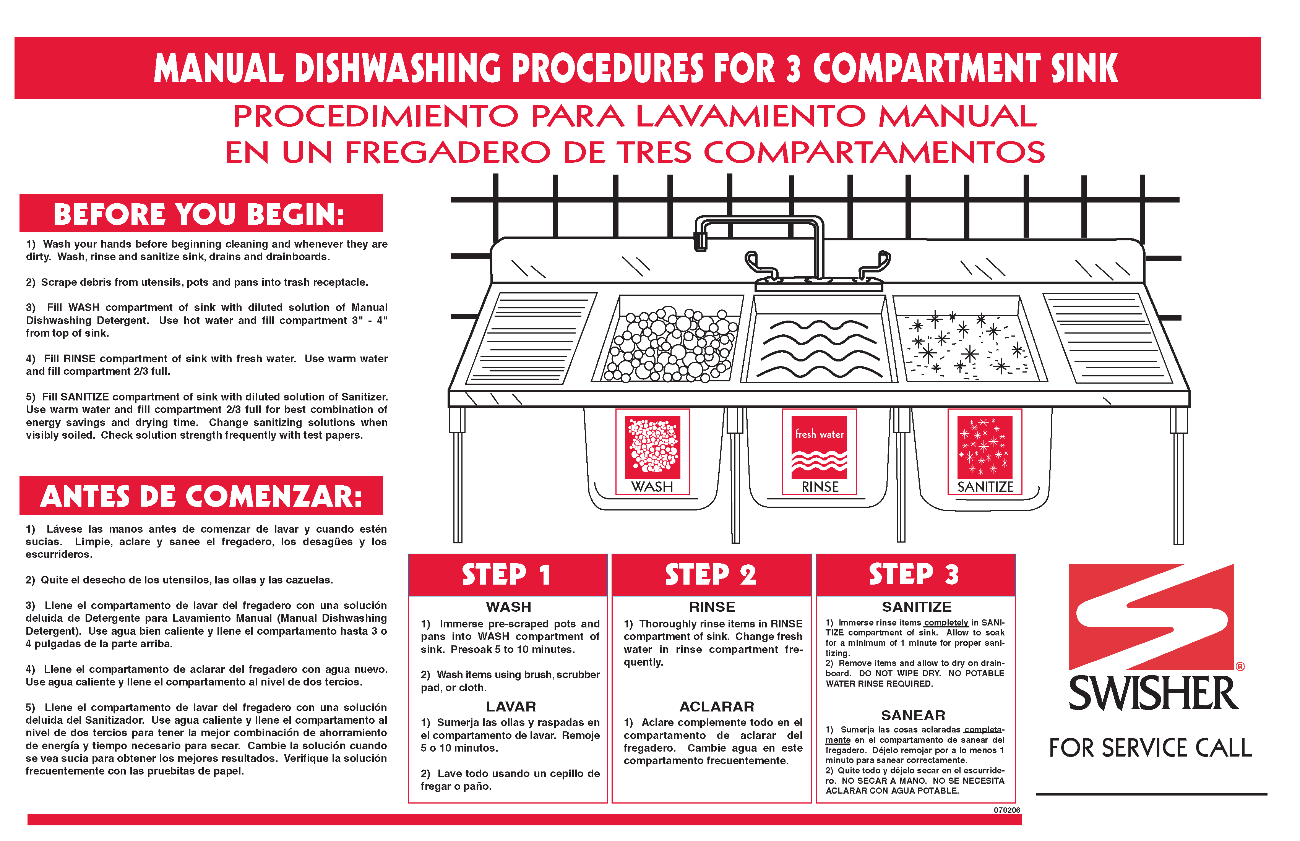

.



Bleach Mixing Procedure

**FOR USE IN ABSENCE OF A SANITIZING SOLUTION\*\***

Normally, **One Tablespoon** (= 15 milliliters = 0.5 liquid ounce) of concentrated bleach **per Gallon** of water at normal room temperature is considered to be the equivalent of **200 PPM**. (Parts Per Million). Depending on the application, the PPM must vary. See below:

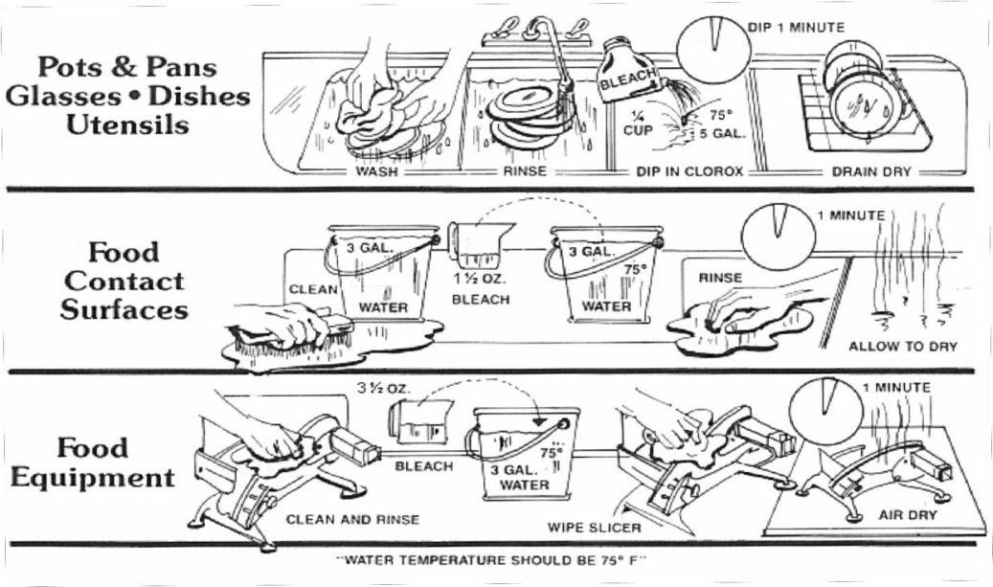

50-100 PPM

100 PPM

200 PPM

* First, the temperature has to be right (hotter temperatures decrease the effectiveness of bleach solutions). Room temp (75°) water is the most effective and should be used.
* Second, the time of exposure has to be at least one minute for a bacterial kill.
* Third, and perhaps most important, the concentration of chlorine MUST BE ADEQUATE.
* 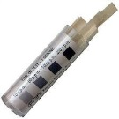**USE CHLORINE TEST STRIPS TO VERIFY PPM**.

Guideline for mixing bleach solutions:

|  |  |  |  |
| --- | --- | --- | --- |
| **Sanitizing Activity** | **Ratio** | **Should Test to Minimum PPM** | **If too Low/ If too High** |
| Pots, Pans, Dishes, and Utensils | 2 ounces/ 5 gallons (~0.3%) | 50-100 PPM | Add More Bleach/ Add More Water |
| Food Contact Surfaces | 1.5 ounces/ 3 gallons (~0.4%) | 100 PPM | Add More Bleach/ Add More Water |
| Food Processing Equipment | 3.5 ounces/ 3 gallons (~1%) | 200 PPM | Add More Bleach/ Add More Water |

Trash Audits

As a dishwasher, another main priority is keeping non-trash items out of the trash! Things fall into the trash that should not, all the time. It is up to you and the rest of the team to salvage those items! Whether it is a fork, knife, sauce, cup, a plate, or a plastic basket! You should be performing trash audits periodically through your shift. There are different ways to make this process easier on the team, and below are a couple different ways.

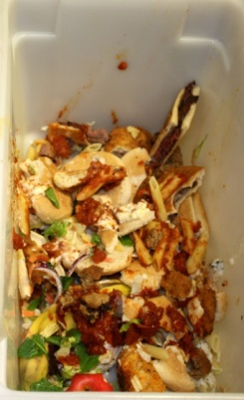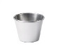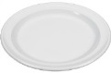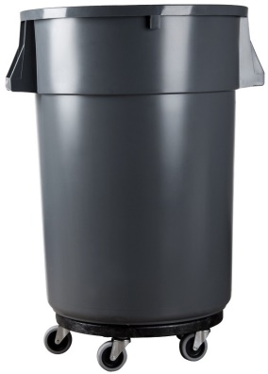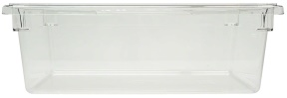

Lexan/trash can method:

This method is the most common among the restaurants. A plastic pan is placed atop the trash can and this is where waste is placed. As the container fills up, it is then allowed to be slowly dumped down into the can below. As it is dumped slowly, silverware/plates/etc. can be easily spotted and salvaged!

Small can/big can method:

This method involves a smaller trash can being used as the main receptacle for the waste. As that smaller can fills up, it is then dumped off into a bigger can. The same process listed above would then be applied to salvage the silverware and other items.

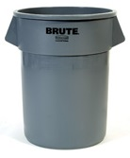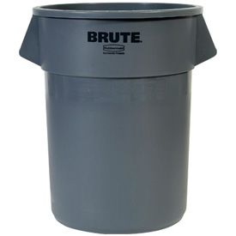

Security/Back Door/Trash Runs:

Security is the highest priority in our restaurants, and it starts with the back door. Our back doors are equipped with alarming devices that are locked (from the outside) and alarmed at all times. Only a manager is able to open the back door and will only open it during certain times of the day. Ensure a manager is present at all times when the back door is open.

**Cody’s Original Roadhouse Dish Final Test**

**Name: _________________________________ Score ______/23**

1. SDS sheets stands for __________________________________________________________.
2. Chemicals are not required to be properly labeled. True or False
3. Three compartment sinks are used for
4. Hand washing dishes when the dish machine is not functioning
5. Prep
6. Soaking silver ware
7. None of the above
8. There are 2 forms of sanitizer- match the following types to the description

Quat based sanitizer is ______________ based.

Chlorine based sanitizer is _____________ based.

1. We use the same type of test strip to test both types of sanitizers. True or False
2. Trash audits are only completed at the end of your shift. True or False
3. Team members may enter or exit through the back door whenever they want. True or False
4. When handling clean dishes, you must
5. Be careful
6. Dry with a towel
7. Wash your hands
8. All of the above
9. As a dishwasher it is your responsibility to
10. Assemble/ Disassemble the dish machine
11. Sweep & mop the floors
12. Remove trash and garbage to the dumpster area
13. All of the above
14. Flatware should be soaked in ______________________________________________________

It should be run through the dish machine in a _________________________ and then sorted in a ________________________________ and ________________________________________.

1. Pots, pans, bowls, cups, etc. should be stored
2. Right side up
3. Upside down
4. Separately
5. 8 inches off of the floor
6. Which is not required to be listed on the label of a chemical?
7. The common name of the chemical
8. An appropriate hazard warning
9. Poison control number
10. The name, address, and phone number of the company responsible for the product
11. Quat sanitizer should read no more than _____ ppm.
12. 50
13. 100
14. 150
15. 200
16. Chlorine sanitizer should read no more than ____ ppm.
17. 50
18. 100
19. 150
20. 200
21. When utilizing the 3 compartment sink dishes should be submerged in the sanitizer for at least ____ minute(s).
22. 1
23. 2
24. 3
25. 5
26. Chemical levels in the dish machine should be checked periodically throughout your shift to ensure proper levels. True or False
27. On the Hazard Communication Standard Pictogram; Exclamation marks represent
28. Carcinogen
29. Flammable
30. Irritant
31. Skin Corrosion
32. The 3 compartment sinks should be used to wash your hands when they are soiled. True or False
33. The dish machine should be reassembled at close after it has been cleaned. True or False
34. SUCCESFULLY LABEL THIS SINK BY WRITING THE CORRECT WORDS IN THE RED BOXES ON THE FRONTS OF THE SINKS. THIS SINK IS A “LEFT TO RIGHT” 3 COMPARTMENT SINK. (3 POINTS)

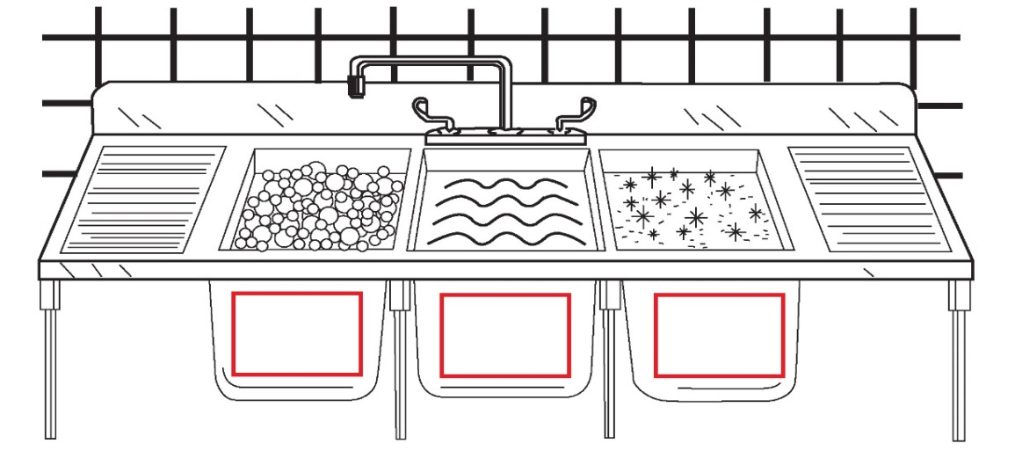

**1.)**

**2.)**

**3.)**